Barak Barclay

Dr. Al Batten

ECE2610-001

Lab 4

**Exercise #5:**

1. h[n]={2,-3,2} 🡪 H(ejw)=2-3e-jw+2e-jw2

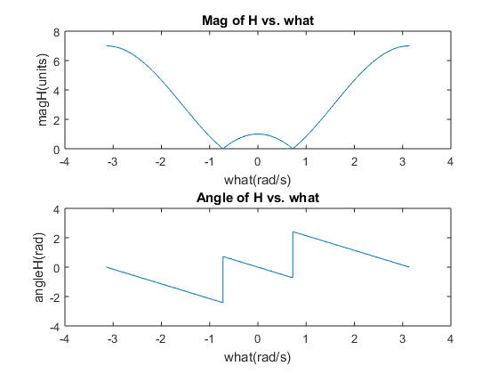

1. The discontinuities are occurring because the frequency response is changing signs at those two what values.
2. The normalized frequencies in which the discontinuities occur is (+/-)0.7227 rad/s.

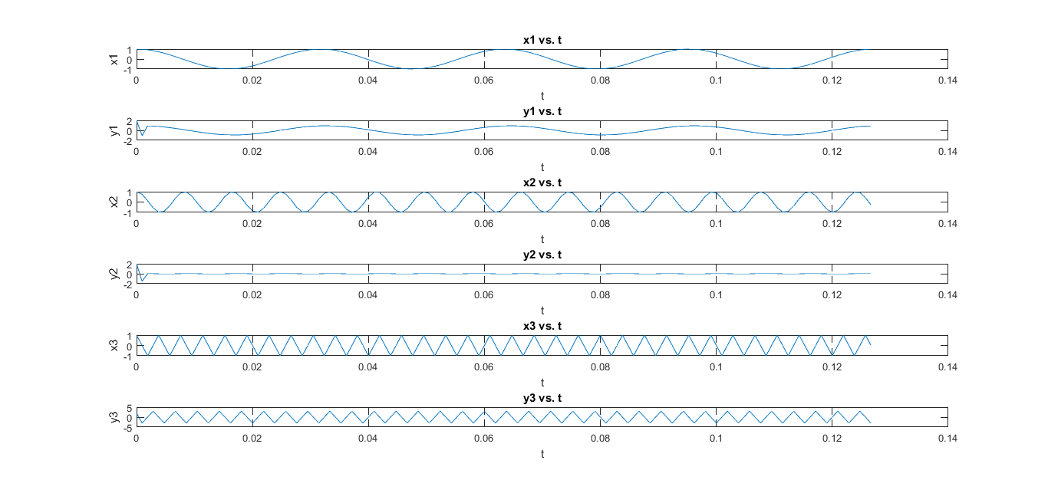

1. When the input sequences go through the filter, the amplitude and phase will be modified, while the frequency stays the same, to give a different sequence for the output. All of the input sequences have the same frequency as the output sequences, in the plots on the last page, but the amplitudes and phases have changed.

4.

>> what = -pi:0.0001:pi;

>> H=2-3*exp(-j*what)+2*exp(-j*what*2);

>> magH = abs(H);

>> angleH = angle(H);

>> subplot(2,1,1), plot(what,magH);

>> subplot(2,1,2), plot(what,angleH);

5.

>> fs=1050;

>> f1=31.5;

>> f2=120.75;

>> f3=262.5;

>> Ts=1/fs;

>> T1=1/31.5;

>> t=[0:1/fs:4/f1];

>> x1=cos(2*pi*f1*t);

>> x2=cos(2*pi*f2*t);

>> x3=cos(2*pi*f3*t);

>> y1=filter([2,-3,2],1,x1);

>> y2=filter([2,-3,2],1,x2);

>> y3=filter([2,-3,2],1,x3);

>> subplot(6,1,1), plot(t,x1);

>> subplot(6,1,2), plot(t,y1);

>> subplot(6,1,3), plot(t,x2);

>> subplot(6,1,4), plot(t,y2);

>> subplot(6,1,5), plot(t,x3);

>> subplot(6,1,6), plot(t,y3);